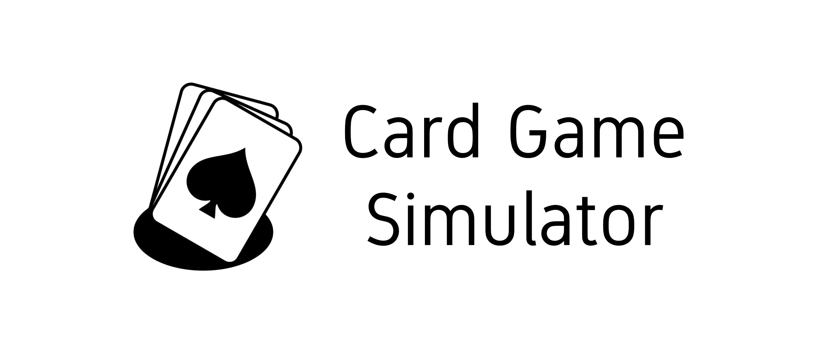

Project Document
Unity Seminar

Project Member: Melanie Sverdlov
Seminar Advisor: Moshe Sulamy

Introduction
Card Game Simulator is a video game that aims to simulate various card games in a tabletop way. Players can choose from a variety of games to play with friends over a local network, without requiring an active internet connection. The game also provides tools to create new game templates for other players to experience and enjoy, with many options to customize their game, in order to bring out their creative vision.
Purpose of the Project
The game aims to provide an enjoyable card game experience, to provide players the ability to play as many different card games as possible, and to allow different methods of playing those games. The game can be used to accomplish two types of uses:
- A complete replacement for playing a card game physically, where it would be preferred or even physically possible over playing with real-life cards. For example: a group of kids playing Taki with their phones on a bus.
- An aid for players for use in card games, and board games that utilize cards in gameplay, for purposes of convenience or accessibility. For example: a game of Monopoly, where players have placed the game map on a real-life table, but the cards and player money management are handled on the simulator by the players.

The idea for this game is based on Tabletop Simulator and Board Game Arena - games that aim to simulate board games as a whole, including card games. Card Game Simulator specializes on card game simulation, and to add convenient features fitting for playing those games. For example: an appropriate and easy-to-use user interface for showing the player's hand, quick access to player actions like drawing a card, shuffling a deck, and so on.

Main Features:
Simulating and Playing Card Games:
Card Game Simulator, as the name suggests, simulates card games in a way that is very similar to playing them on a real-life table. This gives great flexibility for players, gives a more natural playing experience, and encourages communication between players. The simulator is geared towards card games, supports different types of decks, placements, player actions, and simple rules to provide support for playing a wide variety of card games.
View of Table and Player Scores, Inside a Game:
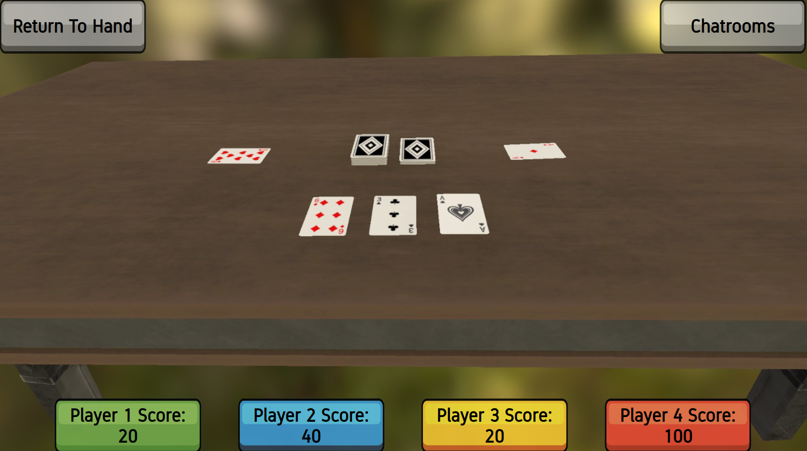

Easily Join Games Nearby:
Players start game instances of their card game of choice, and other players can join the game on their device by finding available games on the local network, without requiring to know the host’s IP or needing an active internet connection. This also allows to quickly and effortlessly start games in social gatherings, simply find a game nearby, and play!
Join Screen Interface:
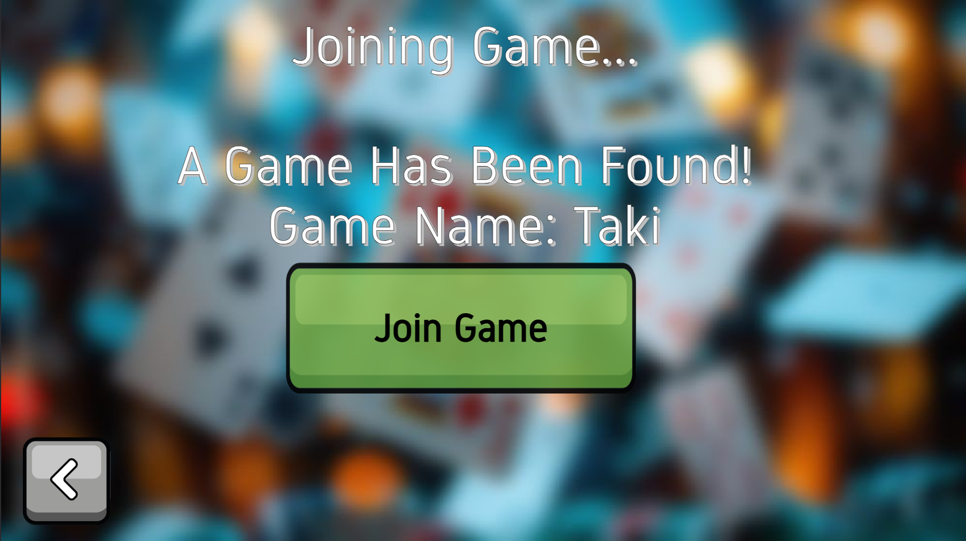
Create and Play Your Own Card Games:
The Card Game Creator gives users the ability to build games of their own, and lets them set up different aspects of the game, such as game cards, decks, player types, chatrooms, player actions, and more.
These game templates allow for quick setup of game instances, such as automatically
handing out cards to players, and placing simple restrictions and permissions for players'
actions. Options are laid out in an easy and simple interface to set up new games, while providing many options to allow for the creation diverse and varying card games.
Once finished creating their game, players can then start and invite other players to enjoy their creation, and then share it among users.

Card Pool Settings in the Card Game Creator:
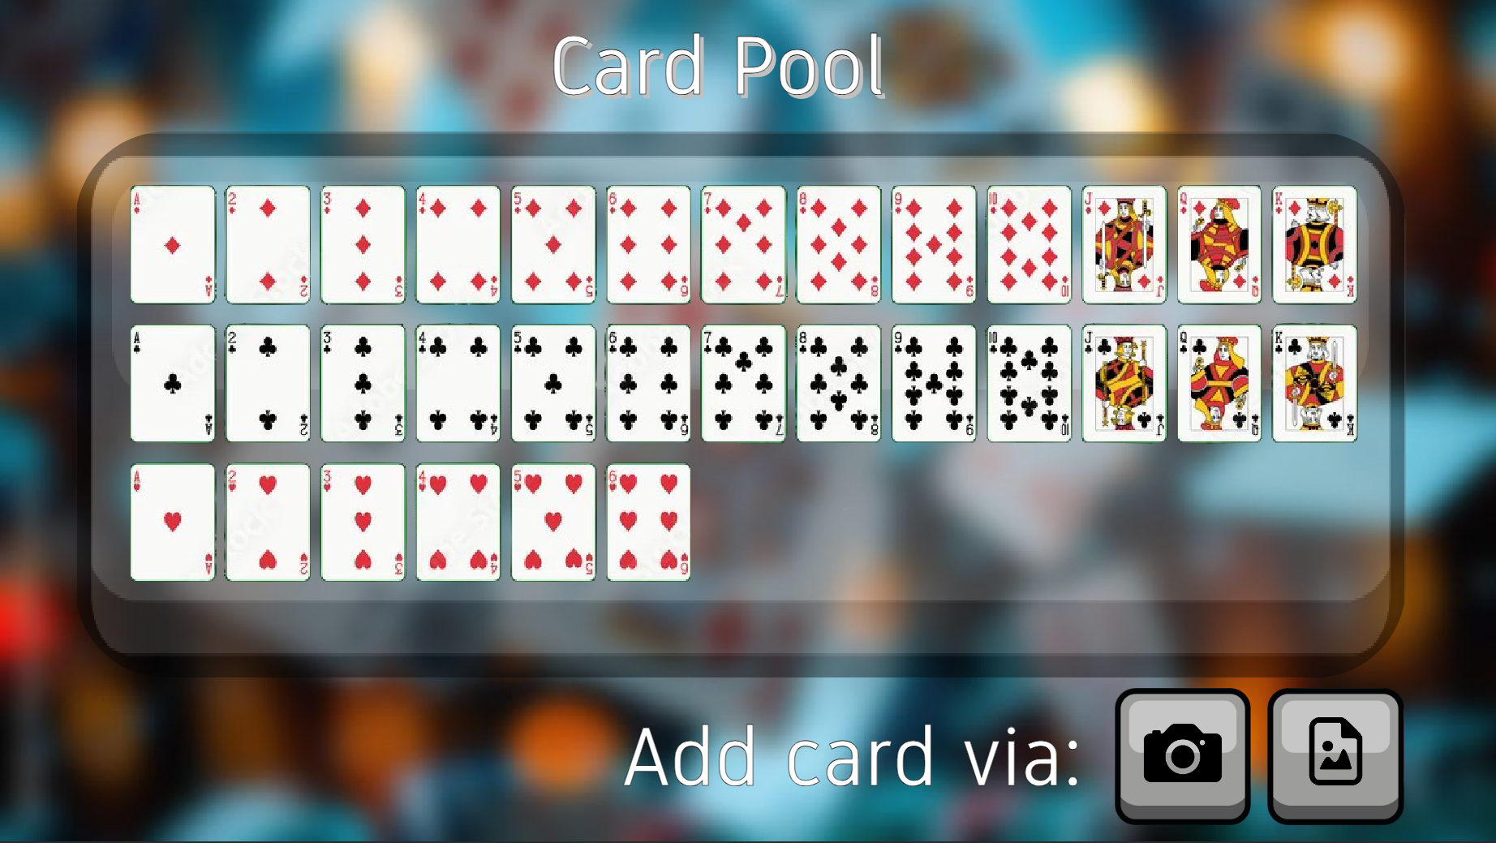
Use a Secondary Device to Show the Game Table:
In a physical meetup, players can use their devices to play, and a secondary device, like a
tablet, can be used to project the current game being played. It can be used to display the
game's table and players' scores on a larger screen, for everyone playing.
Illustration of a tablet showing the game table, and a phone showing a player’s hand:
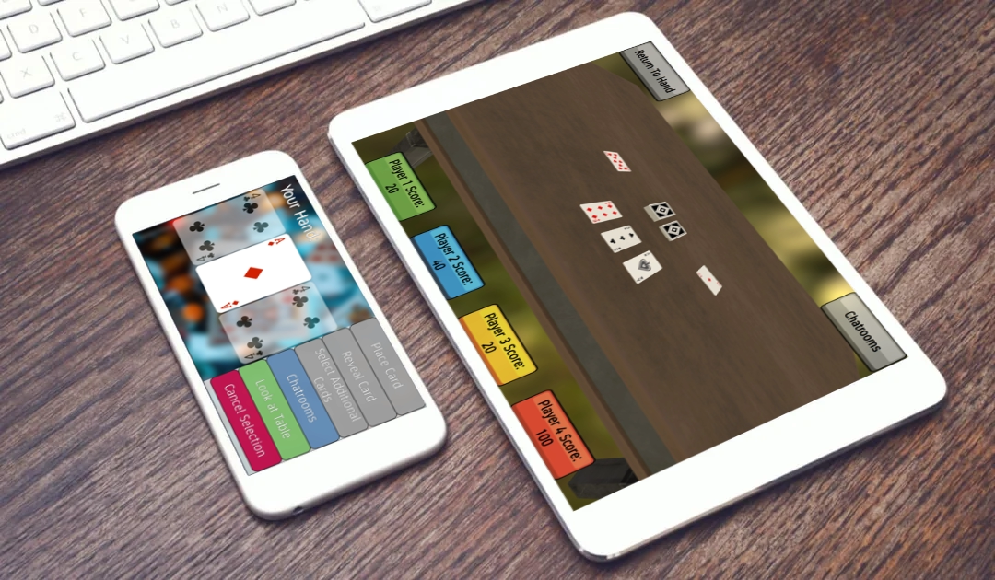
Game Architecture:
System Components
Mobile Device Client: Device wanting to join an active game on the network.
Mobile Device Host: Device creating and hosting new game instance to play their selected card game.
Cloud Database: Server that communicates with its card game database, and serves available card games to play.
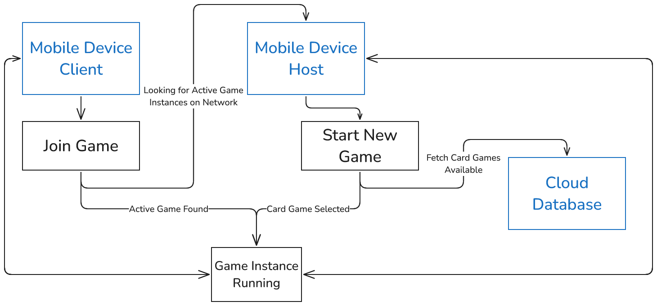

User Flow Diagram
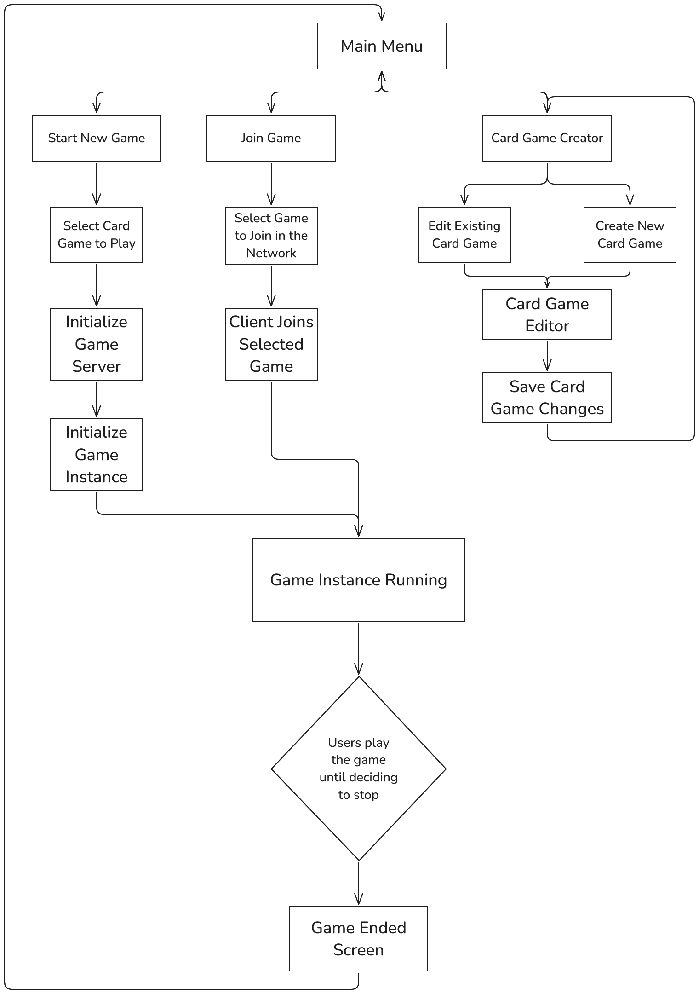

Technologies at Use:
The game client will be built using the Unity game engine, using it to easily and efficiently build up the game simulator, create a comfortable user interface, and to easily add new features and fix potential bugs. Unity allows the game to be developed cross-platform - for desktop and mobile devices, and for different operating systems.
In addition, the game uses Unity’s NetworkDiscovery component, to allow to easily connect to game instances on the same network, without requiring an IP address or connection to the Internet.
The game client software will be developed using the .NET framework, with the development environment being Visual Studio. JetBrains’ ReSharper is used in conjunction with Visual Studio, to help with enhancing code readability, easier refactoring, ensuring consistent code style, and improve the development experience as a whole on Visual Studio.

Testing the Game:
One tool that was used while testing the game was an in-game debugging console, which provides an interface for checking log messages inside of the Unity application. This tool proved very useful for testing and debug multiplayer functionality with multiple game instances running, as well as when testing the game on proper mobile devices.

Problems and Issues During Development:
During the proof-of-concept stage of development, the network protocol considered at the time was Google's Nearby Connections: a peer-to-peer protocol that allows devices to connect to one another without any network connectivity.
Sadly, there is no official support in Unity, and very little documentation and usage of the protocol. There is a third-party basic implementation, but it proved very difficult to intuitively work with it, and to build the whole network infrustruture of the game from scratch. Therefore, to simplify developing the networking functionality, it was decided to switch to a client-server architecture using Unity's NetworkDiscovery.

Extending the Game:
Possible features to implement in the future are:
- Adding a game template repository, for players to easily share game templates with one another.
- Hosting and playing game instances on the Internet, in addition to LAN.
- Adding card descriptions, for explaining the rules and effects of the card.
- Accessibility features, such as font size options for text-only cards, screen reader compatibility, high contrast mode, etc.
- Player-defined action macros, instead of them being only defined in the game template.
- Adding a turn system, where the player who has the current turn can perform actions.
- Custom card height and width, instead having one set of predetermined card dimensions.

